Sitthiphol Yuwanaboon

John O’Neal

CS 130

9 April 2021

Q1 a.

Test with 5 & 20 and print screen at the end. Label it PtA1a. What was the answer? 0x64

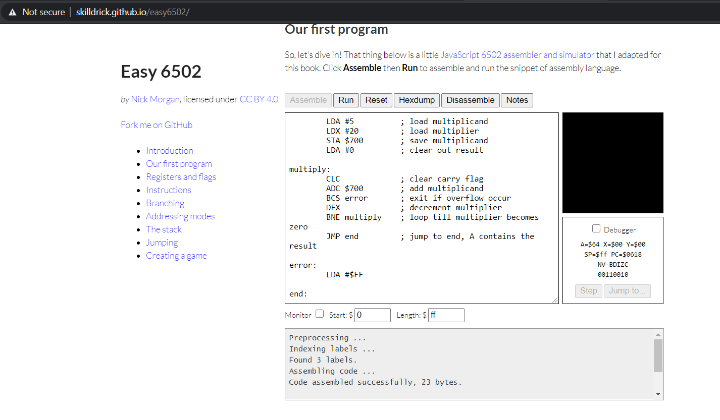

PtA1a

b.

Test with 3 & 120 and print screen at the end. Label it PtA1b. What was the answer? 0xff

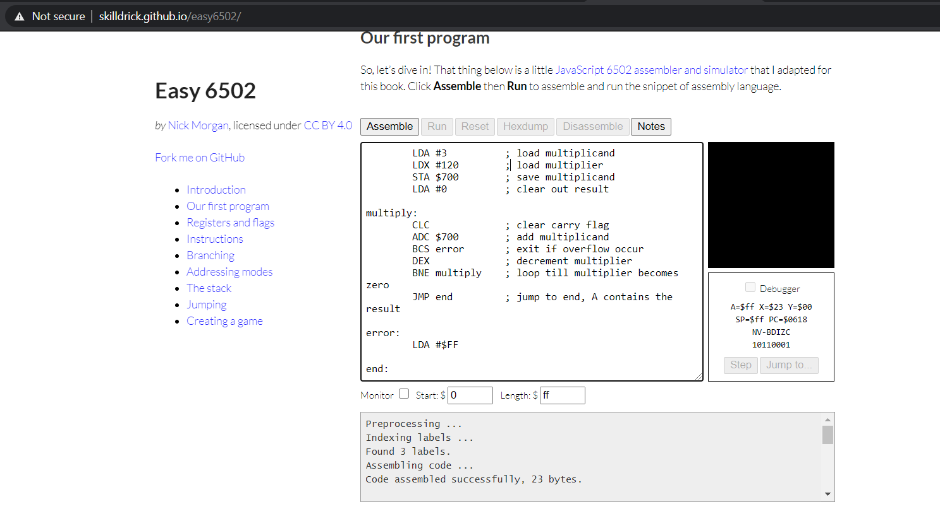

PtA1b

c.

Test with 8 & 31 and print screen at the end. Label it PtA1c. What was the answer? 0xf8

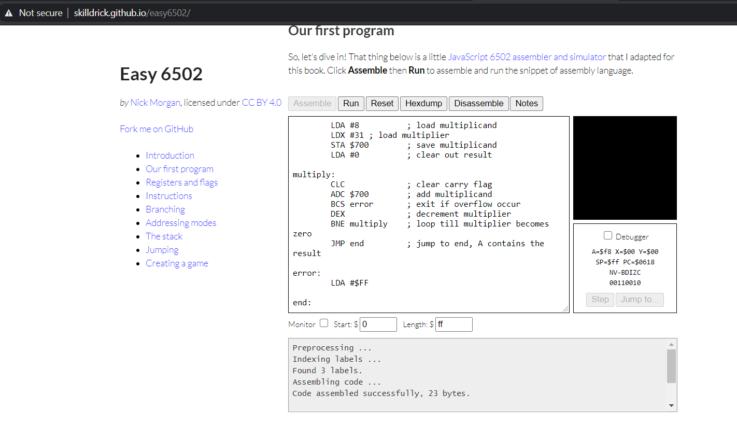

PtA1c

Q2 a.

Test with 20 & 5 and print screen at the end. Label it PtA2a. What was the answer? 0x4

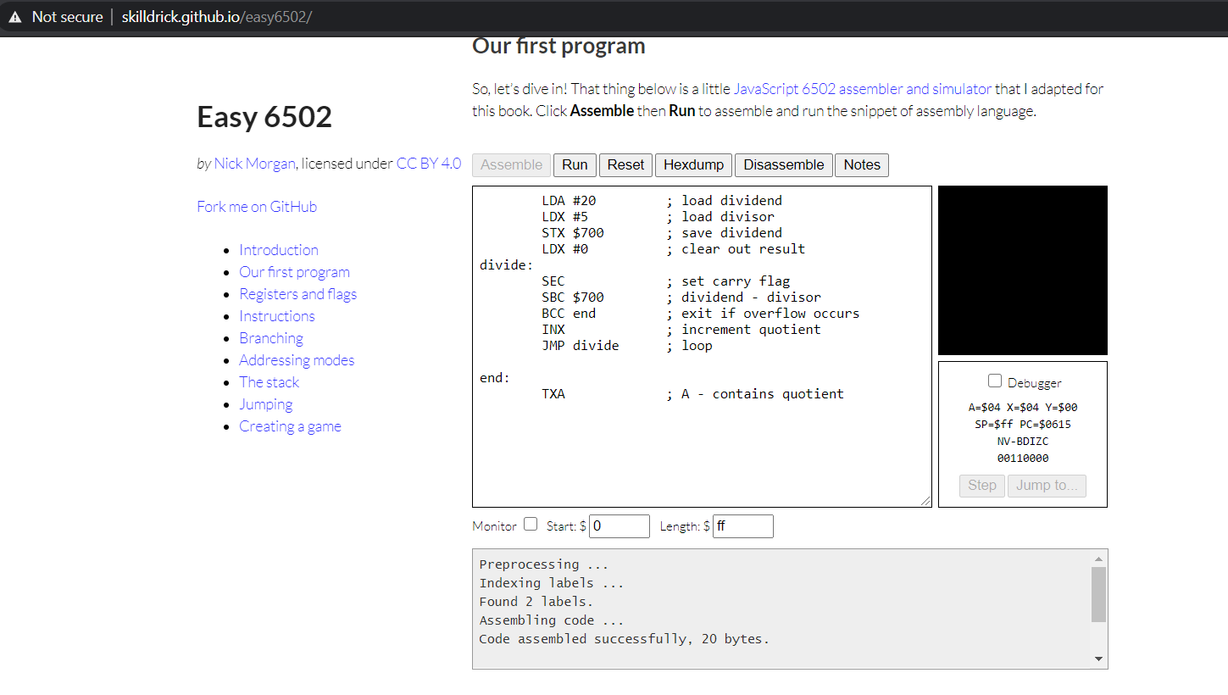

PtA2a

b.

Test with 120 & 3 and print screen at the end. Label it PtA2b. What was the answer? 0x28

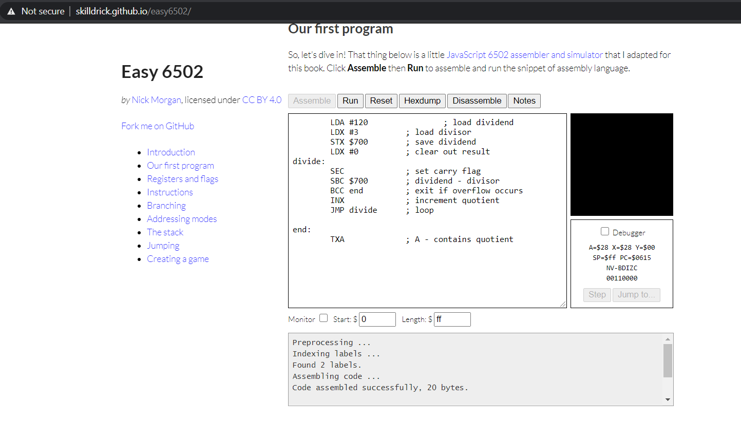

PtA2b

c.

Test with 8 & 32 and print screen at the end. Label it PtA2c. What was the answer? 0x0

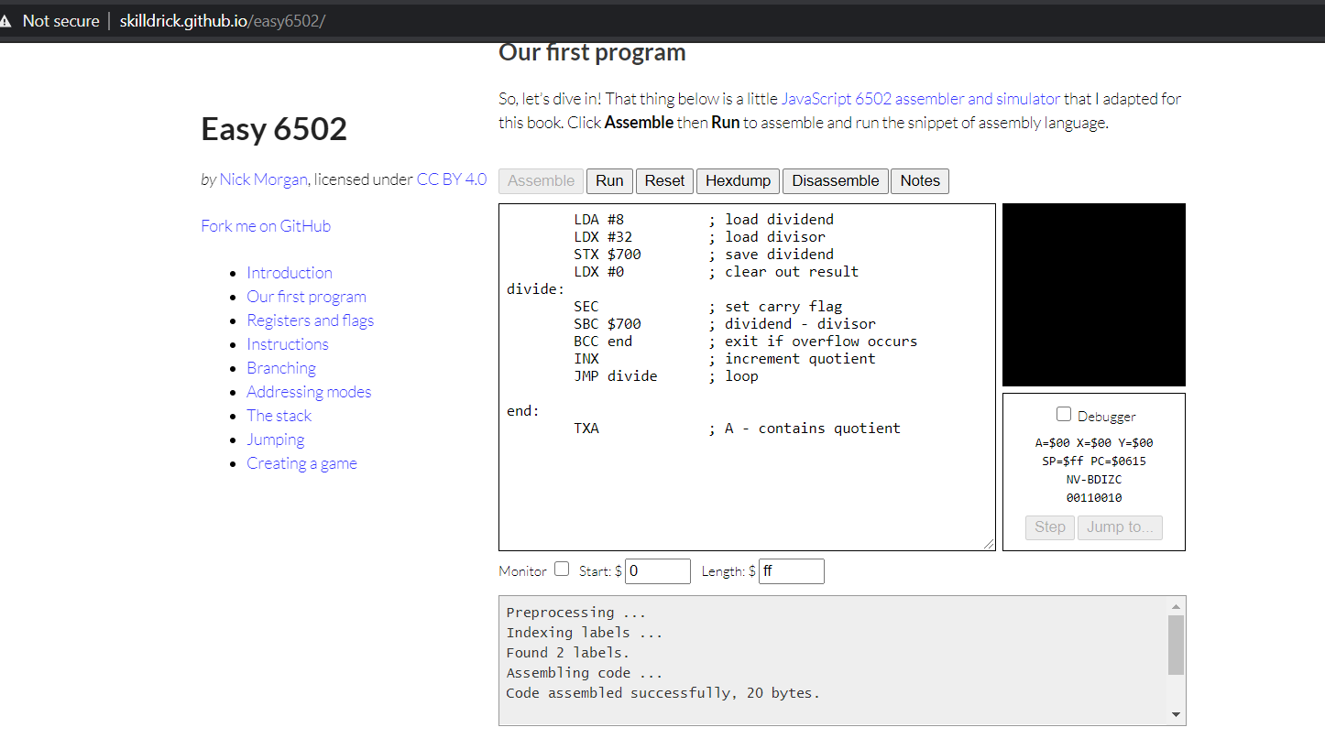PtA2c

Q3 a.

Test with 255 & 255 and print screen at the end. Label it PtA3a. What was the answer? 0xFE01

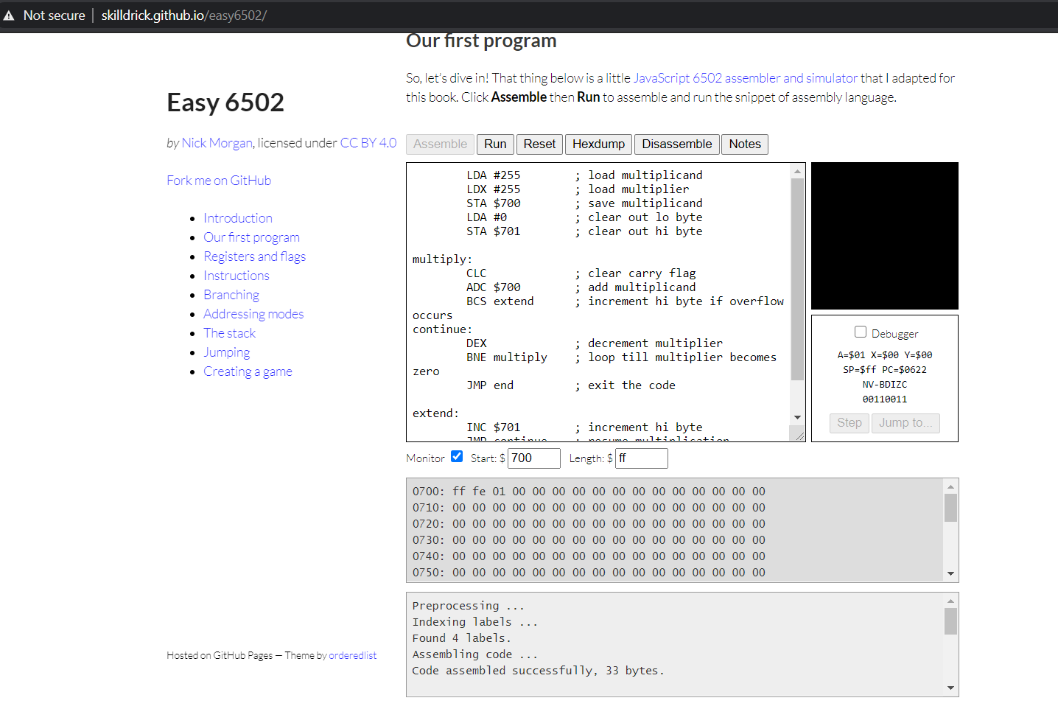

PtA3a

b.

Test with 120 & 57 and print screen at the end. Label it PtA3b. What was the answer? 0x1AB8

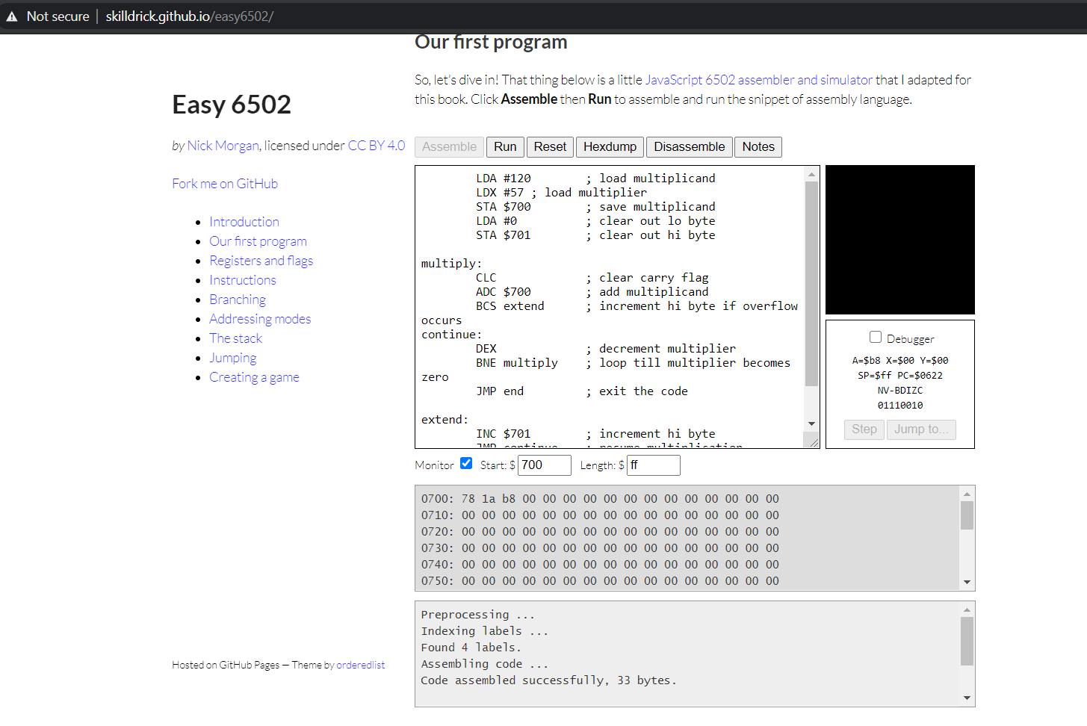

PtA3b

c.

Test with 20 & 5 and print screen at the end. Label it PtA3c. What was the answer? 0x0064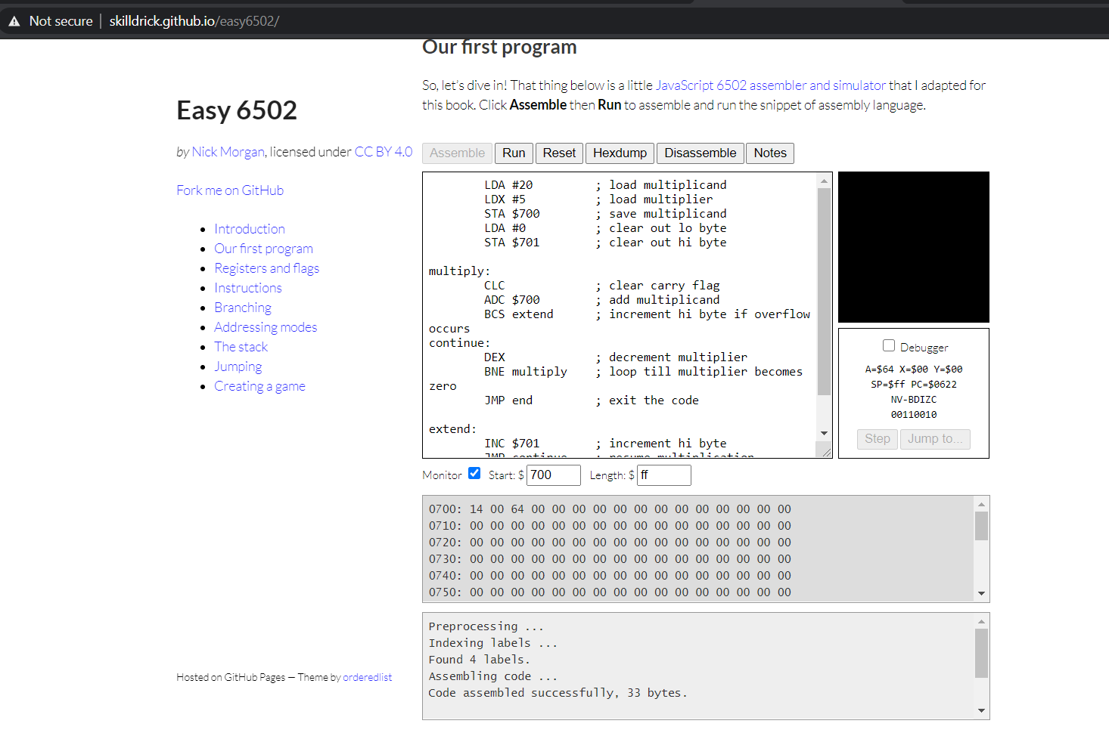

PtA3c

**Part B**

Q1

1. Use 123657 and 8. Label the screenshot PtB1a.

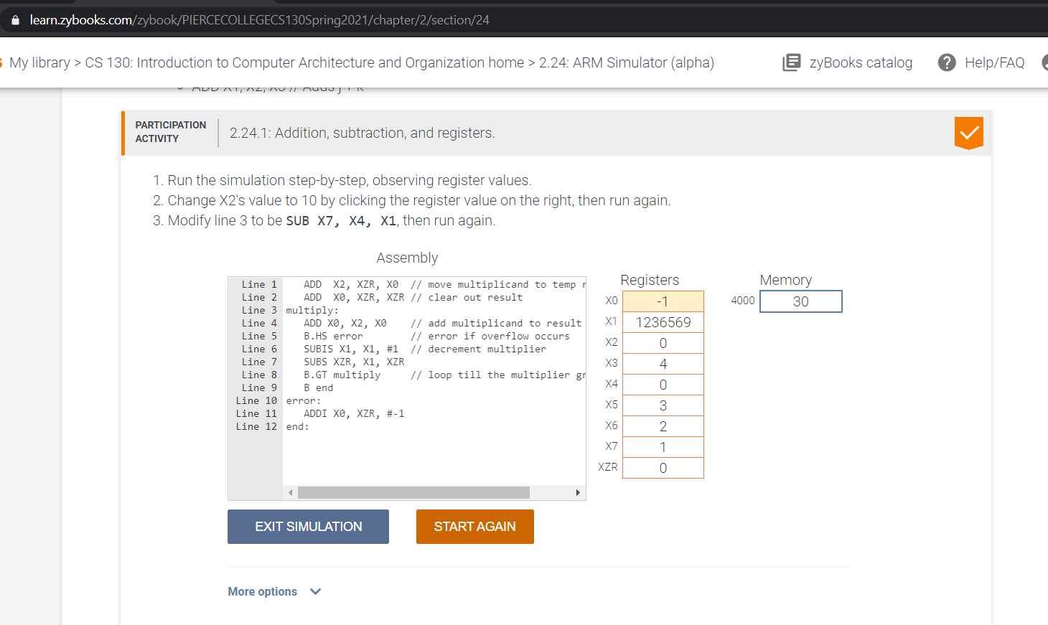

PtB1a

b.

Use 657,839,333,222 and 333,839,657,222. Label the screenshot PtB1b.

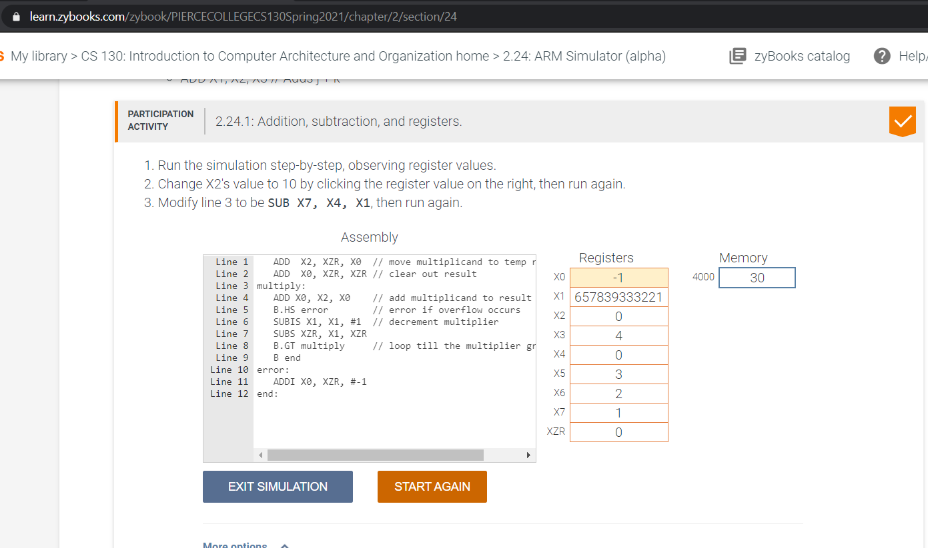

PtB1b

c.

Use 123,700,00 and 800,111,777. Label the screenshot PtB1c

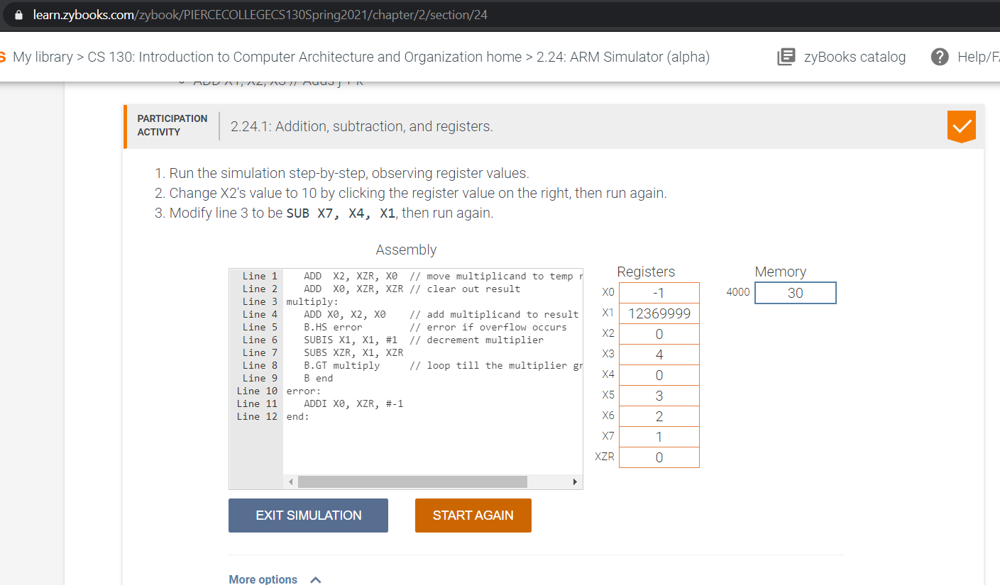

PtB1c

Q2

1. Use 123657 and 8. Label the screenshot PtB2a

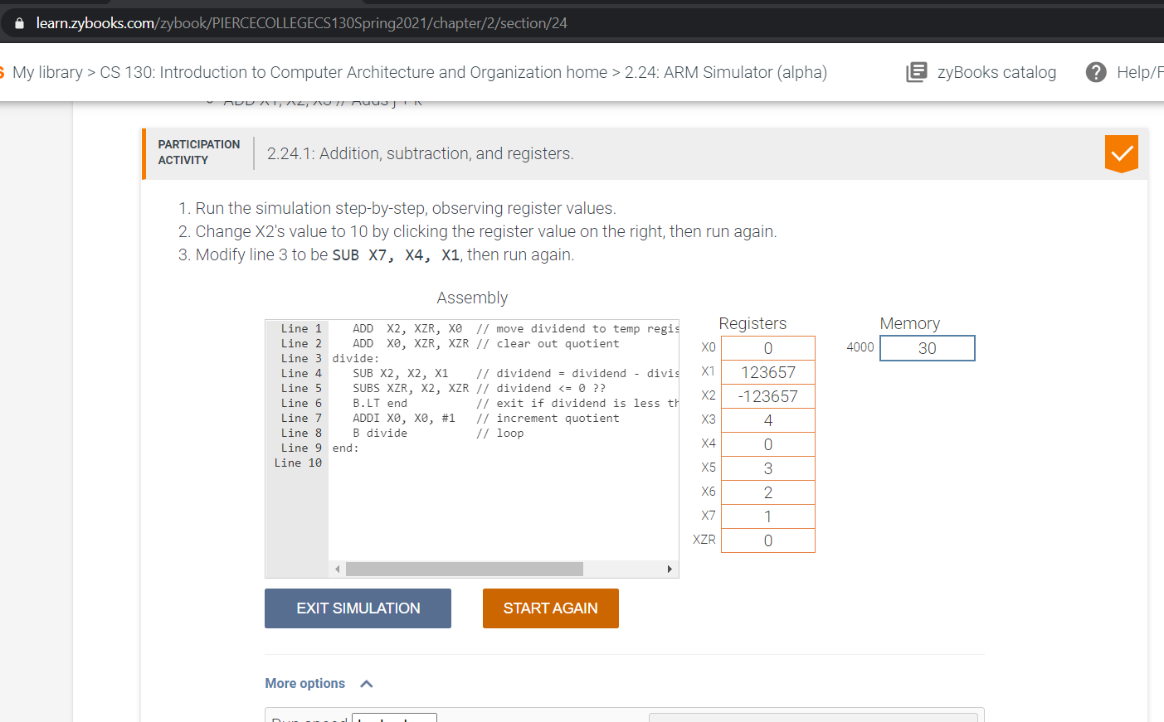

PtB2a

1. Use 657,839,333,222 and 333,839,657,222. Label the screenshot PtB2b.

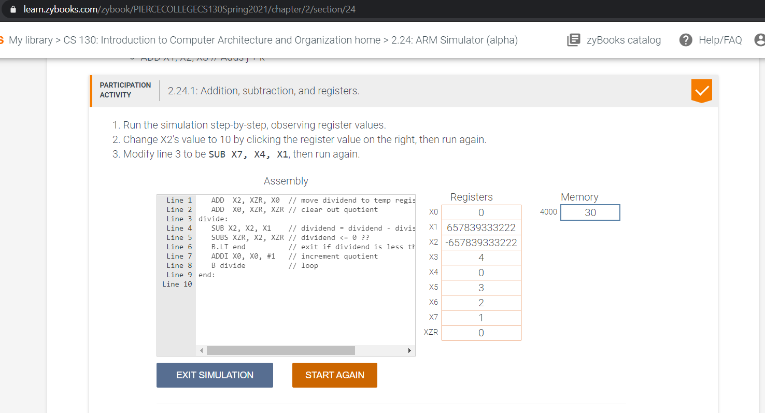

PtB2b

1. Use 123,700,00 and 800,111,777. Label the screenshot PtB1c

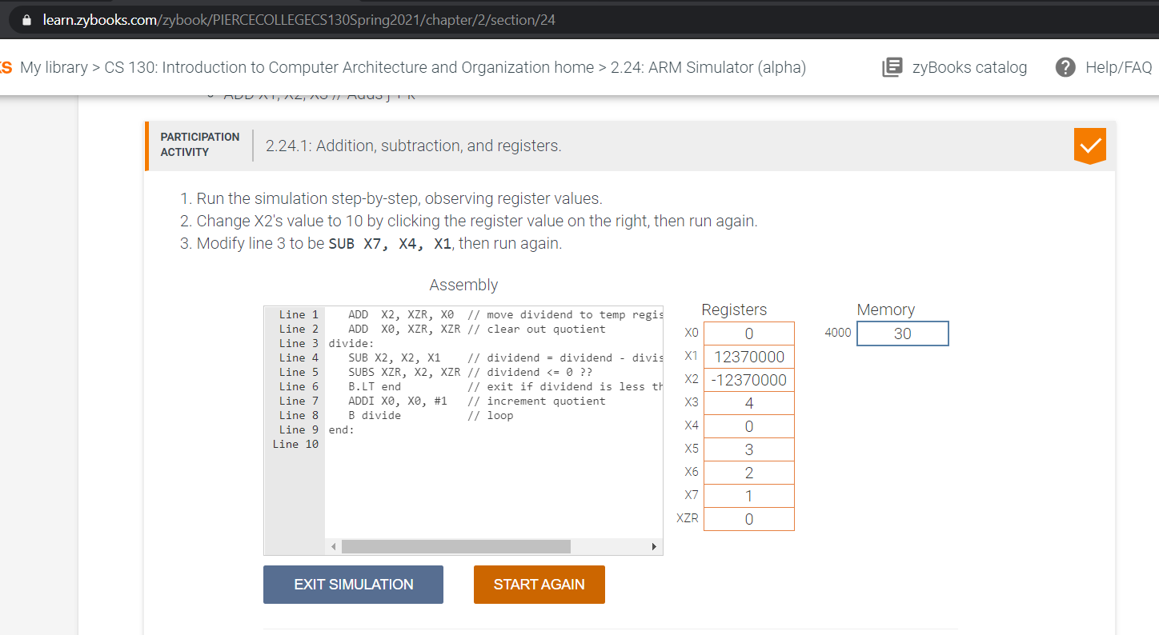

PtB1c